**Batch: A2 Roll No.: 16010121045**

**Experiment / assignment / tutorial No._______**

**Grade: AA / AB / BB / BC / CC / CD /DD**

**Signature of the Staff In-charge with date**

**Experiment No. 1**

|  |
| --- |
| **TITLE:**  Study of Networking devices (Hub, router, Gateway, Switch etc.) and Transmission Media |

**________________________________________________________________________**

**AIM:** To study different Networking devices and transmission media used in day to day networks.

**_______________________________________________________________________**

**Expected Outcome of Experiment:**

**CO:**

**________________________________________________________________________**

**Books/ Journals/ Websites referred:**

1. A. S. Tanenbaum, “Computer Networks”, Pearson Education, Fourth Edition
2. B. A. Forouzan, “Data Communications and Networking”, TMH, Fourth Edition

___________________________________________________________________________

**Pre Lab/ Prior Concepts:** Basics of LAN and Connecting devices

**________________________________________________________________________**

**New Concepts to be learned:** Layer wise connecting devices

**________________________________________________________________________**

**Stepwise-Procedure:**

# Study of Connecting Devices

# Hub

A hub is a physical layer networking device which is used to connect multiple devices in a network. They are generally used to connect computers in a LAN.

A hub has many ports in it. A computer which intends to be connected to the network is plugged in to one of these ports. When a data frame arrives at a port, it is broadcast to every other port, without considering whether it is destined for a particular destination or not.

A hub can be used with both digital and analog data. Hubs do not perform packet filtering or addressing function, they send the data packets to all the connected devices.

Types:

* Active Hub
* Passive Hub
* Intelligent Hub

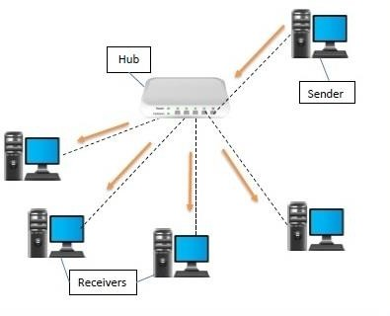

# Repeater

A repeater operates at the physical layer of the OSI model.

* + A Repeater connects two segments of a network cable.
  + Sometimes it regenerates the signals to proper amplitudes and sends them to the other segment.
  + If the signal becomes weak, it can copy the signal bit by bit and regenerate it at the original strength.
  + It is a 2-port device.

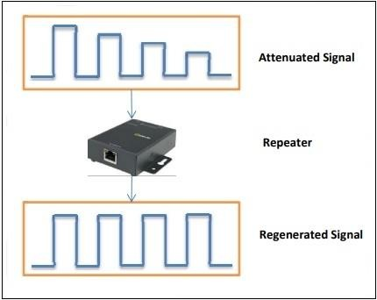

Types of Repeaters

According to the types of signals that they regenerate, repeaters can be classified into two categories:

* + - **Analog Repeaters** − They can only amplify the analog signal.
    - **Digital Repeaters** − They can reconstruct a distorted signal.

According to the types of networks that they connect, repeaters can be categorized into two types

−

* + - **Wired Repeaters** − They are used in wired LANs.
    - **Wireless Repeaters** − They are used in wireless LANs and cellular networks.

According to the domain of LANs they connect, repeaters can be divided into two categories −

* **Local Repeaters** − They connect LAN segments separated by small distance.
* **Remote Repeaters** − They connect LANs that are far from each other.

Advantages of Repeaters

* + Repeaters are simple to install and can easily extend the length or the coverage area of networks.
    - They are cost effective.
    - Repeaters don’t require any processing overhead. The only time they need to be investigated is in case of degradation of performance.
    - They can connect signals using different types of cables.

Disadvantages of Repeaters

# 

* Repeaters cannot connect dissimilar networks.
* They cannot differentiate between actual signal and noise.
* They cannot reduce network traffic or congestion.
* Most networks have limitations upon the number of repeaters that can be deployed.

1. **Switch**

A network switch is a computer networking device that connects various devices together on a single computer network. It may also be used to route information in the form of electronic data sent over networks. Since the process of linking network segments is also called bridging, switches are usually referred to as bridging devices.

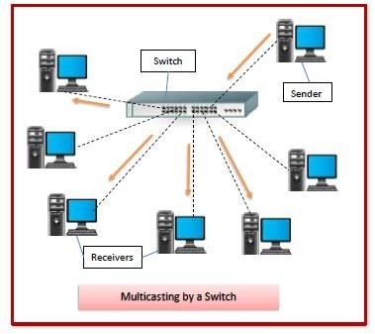

# Type of Switch

* + **Manageable Switches**: Manageable switch has a console port and IP address, which can be assigned and configured.
  + **Unmanageable Switches:** On an Unmanageable switch, configuration can't be made. It is not possible to assign IP address as there is no console port.

# Advantages of Switch:

* + - It helps you to reduce the number of broadcast domains.
    - Supports VLAN's that can help in Logical segmentation of ports
    - Switches can make use of CAM table for Port to MAC mapping

# Disadvantages of Switch:

* + - Not as good as a router for limiting Broadcasts
    - Communication between VLAN's requires inter VLAN routing, but these days, there are many Multilayer switches available in the market.
    - Handling Multicast packets that requires quite a bit of configuration & proper designing.
    - Reduces the number of Broadcast domains

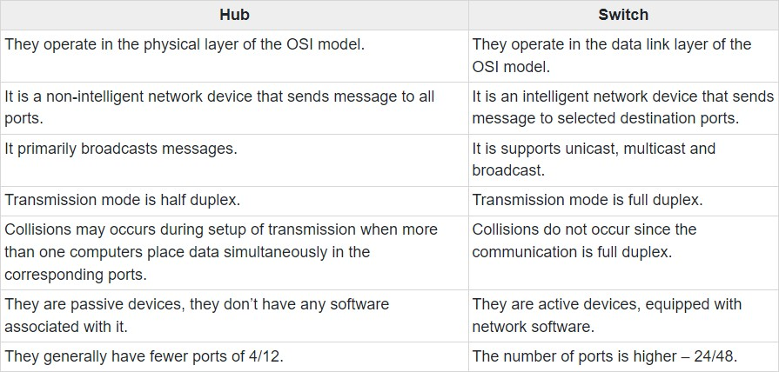

## Bridge

Bridges are used to connect two subnetworks that use interchangeable protocols. It combines two LANs to form an extended LAN. The main difference between the bridge and repeater is that the bridge has a penetrating efficiency.

Working of Bridges:

A bridge accepts all the packets and amplifies all of them to the other side. The bridges are intelligent devices that allow the passing of only selective packets from them. A bridge only passes those packets addressed from a node in one network to another node in the other network.

A bridge performs in the following aspect −

* + A bridge receives all the packets or frame from both LAN (segment) A and B.
    - A bridge builds a table of addresses from which it can identify that the packets are sent from which LAN (or segment) to which LAN.
    - The bridge reads the send and discards all packets from LAN A sent to a computer on LAN A and that packets from LAN A send to a computer on LAN B are retransmitted to LAN B.
    - The packets from LAN B are considered in the same method.

Uses:

The main uses of bridges are −

* + - * Bridges are used to divide large busy networks into multiple smaller and interconnected networks to improve performance.
      * Bridges also can increase the physical size of a network.
      * Bridges are also used to connect a LAN segment through a synchronous modem relation to another LAN segment at a remote area.

Types:

1. Transparent Bridges
2. Source Routing Bridge

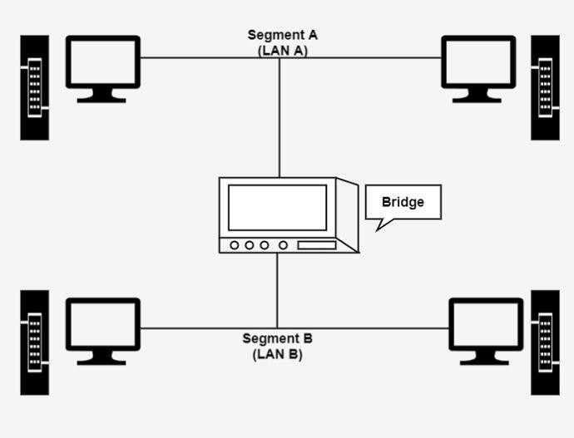

## Router

Routers are networking devices operating at layer 3 or a network layer of the OSI model. They are responsible for receiving, analysing, and forwarding data packets among the connected computer networks. When a data packet arrives, the router inspects the destination address, consults its routing tables to decide the optimal route and then transfers the packet along this route. It is also known as an intelligent device as it can calculate the best route to pass the network packets from source to the destination automatically. It serves two primary functions: managing traffic between these networks by forwarding data packets to their intended IP addresses, and allowing multiple devices to use the same Internet connection.

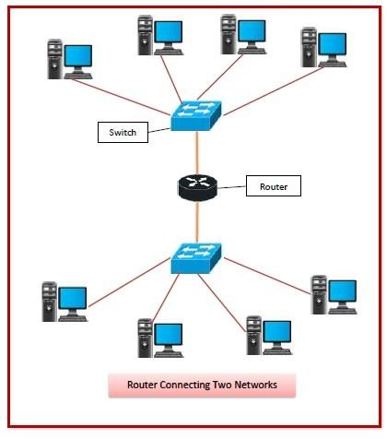

Characteristics

* + Routers constantly monitor the condition of the network, as a whole to dynamically adapt to changes in the condition of the network.
  + It connects different networks together and sends data packets from one network to another.
  + They typically provide some level of redundancy so that they are less susceptible to catastrophic failure.
  + Routers are multiport devices with high - speed backbones.
  + Routers also support filtering and encapsulation like bridges

## Gateway

A gateway, as the name suggests, is a passage to connect two networks together that may work upon different networking models/transmission protocols. They basically work as the messenger agents that take data from one system, interpret it, and transfer it to another system. Gateways are also called protocol converters and can operate at any network layer. Gateways are generally more complex than switches or routers. It acts as the entry – exit point for a network since all traffic that flows across the networks should pass through the gateway.

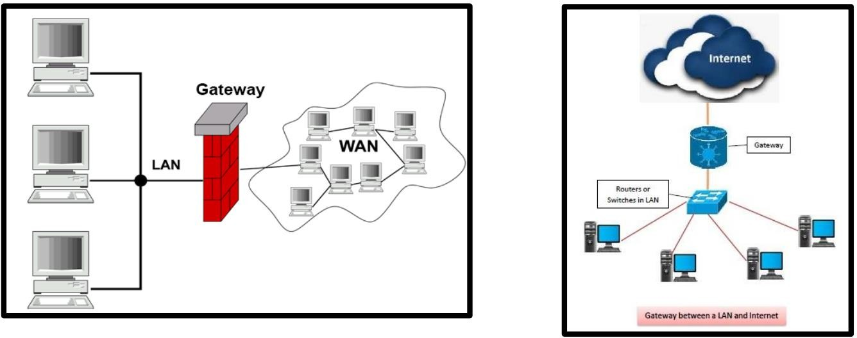

## Characteristics:

* + Gateway is located at the boundary of a network and manages all data that inflows or outflows from that network.
  + It forms a passage between two different networks operating with different transmission protocols. A gateway operates as a protocol converter, providing compatibility between the different protocols used in the two different networks.
  + It uses packet switching techniques to transmit data across the networks

**Study of Transmission Media**

The below information is given for reference purpose only; you need to replace this with the information you have searched

**1. Twisted pair cable**

In balanced pair operation, the two wires carry equal and opposite signals and the destination detects the difference between the two. This is known as differential mode transmission. Noise sources introduce signals into the wires by coupling of electric or magnetic fields and tend to couple to both wires equally. The noise thus produces a common-mode signal which is cancelled at the receiver when the difference signal is taken.

This method starts to fail when the noise source is close to the signal wires; the closer wire will couple with the noise more strongly and the common-mode rejection of the receiver will fail to eliminate it. This problem is especially apparent in telecommunication cables where pairs in the same cable lie next to each other for many miles. One pair can induce crosstalk in another and it is additive along the length of the cable. Twisting the pairs counters this effect as on each half twist the wire nearest to the noise-source is exchanged.

Provided the interfering source remains uniform or nearly so, over the distance of a single twist, the induced noise will remain common-mode. Differential signalling also reduces electromagnetic radiation from the cable, along with the associated attenuation allowing for greater distance between exchanges.

The twist rate (also called pitch of the twist, usually defined in twists per meter) makes up part of the specification for a given type of cable. Where nearby pairs have equal twist rates, the same conductors of the different pairs may repeatedly lie next to each other, partially undoing the benefits of differential mode. For this reason it is commonly specified that, at least for cables containing small numbers of pairs, the twist rates must differ.[

UTP cables are found in many Ethernet networks and telephone systems. For indoor telephone applications, UTP is often grouped into sets of 25 pairs according to a standard 25-pair color code originally developed by AT&T Corporation. A typical subset of these colors (white/blue, blue/white, white/orange, orange/white) shows up in most UTP cables. The cables are typically made with copper wires measured at 22 or 24 American Wire Gauge (AWG),[3] with the colored insulation typically made from an insulator such as polyurethane and the total package covered in a polyurethane jacket.

For urban outdoor telephone cables containing hundreds or thousands of pairs, the cable is divided into smaller but identical bundles. Each bundle consists of twisted pairs that have different twist rates. The bundles are in turn twisted together to make up the cable. Pairs having the same twist rate within the cable can still experience some degree of crosstalk. Wire pairs are selected carefully to minimize crosstalk within a large cable.

Unshielded twisted pair cable with different twist rates

UTP cable is also the most common cable used in computer networking. Modern Ethernet, the most common data networking standard, can use UTP cables. Twisted pair cabling is often used in data networks for short and medium length connections because of its relatively lower costs compared to optical fiber and coaxial cable.

UTP is also finding increasing use in video applications, primarily in security cameras. Many cameras include a UTP output with screw terminals; UTP cable bandwidth has improved to match the baseband of television signals. As UTP is a balanced transmission line, a balun is needed to connect to unbalanced equipment, for example any using BNC connectors and designed for coaxial cable.

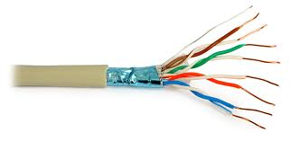

Fig 7.Twisted Pair Cable

**2. Coaxial cable**

Coaxial cable is the kind of copper cable used by cable TV companies between the community antenna and user homes and businesses. Coaxial cable is sometimes used by telephone companies from their central office to the telephone poles near users. It is also widely installed for use in business and corporation Ethernet and other types of local area network.

Coaxial cable is called "coaxial" because it includes one physicalchannel that carries the signal surrounded (after a layer of insulation) by another concentric physical channel, both running along the same axis. The outer channel serves as a ground. Many of these cables or pairs of coaxial tubes can be placed in a single outer sheathing and, with repeaters, can carry information for a great distance.

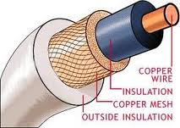

Fig 8.Coaxial Cable

**Optical Fiber**

Fiber-optic communication is a method of transmitting information from one place to another by sending pulses of light through an optical fiber. The light forms an electromagnetic carrier wave that is modulated to carry information. First developed in the 1970s, fiber-optic communication systems have revolutionized the telecommunications industry and have played a major role in the advent of the Information Age. Because of its advantages over electrical transmission, optical fibers have largely replaced copper wire communications in core networks in the developed world.

The process of communicating using fiber-optics involves the following basic steps: Creating the optical signal involving the use of a transmitter, relaying the signal along the fiber, ensuring that the signal does not become too distorted or weak, receiving the optical signal, and converting it into an electrical signal.

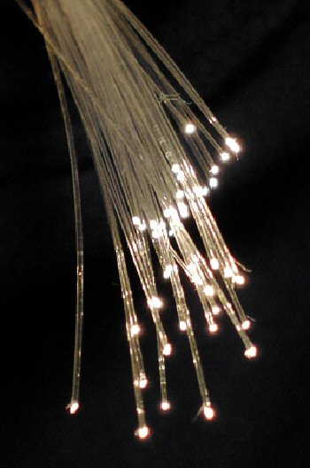

Fig 9.Fiber Optics Cable

**Summary**

The features of the connecting devices and transmission media can be explained in brief as follows:

**CONCLUSION:**

**Post Lab Questions**

1. Compare Hub, switch, bridge, and gateway and specify the use in different cases.

|  |  |  |  |
| --- | --- | --- | --- |
| Hub | Switch | Bridge | Gateway |
| A hub, in the context of networking, is a hardware device that relays communication data. A hub sends data packets (frames) to all devices on a network, regardless of any MAC addresses contained in the data packet. | A switch, in the context of networking is a high- speed device that receives incoming data packets and redirects them to their destination on a local area network (LAN). | A bridge is a network device that connects multiple LANs (local area networks) together to form a larger LAN. | A gateway is a passage to connect two networks together that may work upon different networking models/transmission protocols. They basically work as the messenger agents that take data from one system, interpret it, and transfer it to another system. |
| Operates at layer 1 of the OSI model. (Physical Layer) | Operates at layer2 of the OSI model. (Data Link Layer) | Operates at layer2 of the OSI model. (Data Link Layer) | Operates at layer3 of the OSI model.  (Network Layer) |
| Doesn’t work with MAC  address. | Work with MAC address. | Work with MAC address. | Works with MAC address. |
| Broadcasts incoming traffic on all ports. | to destination node | Routes traffic towards their addressed destinations only. | It acts as the entry – exit point for a network since all traffic that flows across the networks should pass through the gateway. |
| Number of ports range from 4-12. | Number of ports range from 5-52. | 2 port-device. | 2 port-device. |
| It is a passive device. | It is an active device. | It is an active device. | It is an active device. |
| Used to connect multiple devices over the network.It is commonly used to connect segments of a LAN (Local Area Network). | A switch is a hardware device that filters and forwards network packets from one networking device (switch, router, computer, server, etc.) to another. | Bridges connects two or more different LANs that has a similar protocol and provides communication between the devices (nodes) in them. | The gateway converts information, data or other communications from one protocol or format to another. |

1. Which of the following device is used to connect two systems, especially if the systems use different protocols?

A.hub

B.bridge

C.gateway

D.repeater

E.None of the above

1. Frames from one LAN can be transmitted to another LAN via the device

A. Router

B. Bridge

C. Repeater

D. Modem